Month | Dates to Note
 | Wednesday, 28th August - school re-opens at 9:10 a.m.
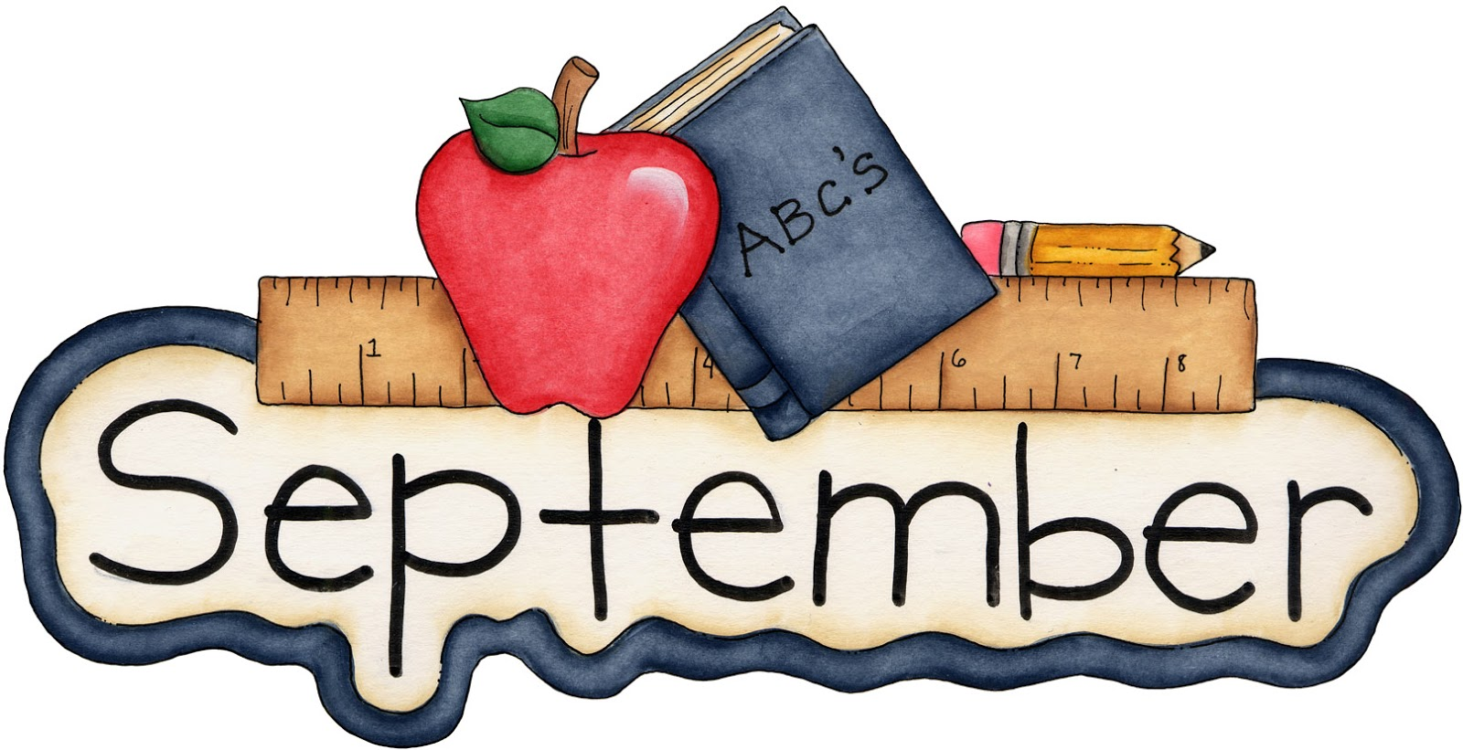 | No closures
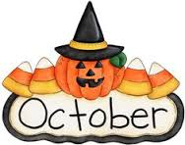 | Monday, 28th October until Friday, 1st November – school closed for Autumn Mid Term
 | Monday, 4th November – school re-opens at 9:10 a.m.
 | Friday, 20th December – school finishes for all children at 12:00 p.m. for Christmas Holidays
 | Monday, 6th January 2020 – school re-opens at 9:10 a.m.
 | Thursday, 20th and Friday, 21st February – school closed for Spring Mid Term
Monday 16th & Tuesday 17th March - school closed for St. Patrick’s Day
Wednesday, 18th March – school re-opens at 9:10 a.m.

Friday, 3rd April – school finishes at 12:00 p.m. for all pupils for Easter Holidays

Monday, 20th April – school re-opens at 9:10 a.m.

 | Monday, 4th & Tuesday, 5th May – school closed for May Bank Holiday
Friday, 29th May & Monday, 1st June – school closed for June Bank Holiday

Wednesday, 24th June – school finishes at 12:00 p.m. for all pupils for Summer Holidays

