

Charleville National School

**2nd – 5th June 2020**

|  |  |
| --- | --- |
| **Class: Junior Infants** | **Teacher: Alison Dunican** |

|  |  |
| --- | --- |
| **Core Subjects (Recommended to be completed daily):** | |
| **Monday** | Bank holiday  sun-47083_640[1] No Home School !! sun-47083_640[1]  cropped-chiquita-dm2-minion-dave-bananas[1] |
| **Tuesday** | **Literacy**   * **Fun at Home** reading book: pages 12-16 **Yoga** –access online reading books on [www.cjfallon.ie](http://www.cjfallon.ie) (Junior Infants, English, Rainbow Stage 1, Fun at Home Core Reader2) * [www.oxfordowl.co.uk](http://www.oxfordowl.co.uk) (see previous instructions for access)   Select **Read Write Inc.** from the **Browse by Series** menu  Scroll down to **Get Up!**  Read p. 6-9 **Get Up!** And ask the questions on p.22 afterwards.   * **Pre-Reading Activity Book**: p.78 + 79   **Maths**   * [**www.cjfallon.ie**](http://www.cjfallon.ie) * Weblink Activities 70 + 71 * **Big Busy at Maths:** p. 70 + 71 * <https://www.abcya.com/games/counting_fish>   **Gaeilge**   * [**www.folensonline.ie**](http://www.folensonline.ie) * Type **Abair Liom A** into the search space * Select **Resources** * Click on **Lesson** and select **Teidí Beag Álainn** * Select **Póstaer – Teidí Beag Álainn**   (after each activity, click the house button to return to the screen)  **Scéal:** listen to the story   * **Foclóir 1:** Press play, listen and click on the correct picture, say the word * **Cuardach 2:** click on the pictures in the poster. Listen and repeat the words / phrases * **Ámhrán: Teidí Beag Álainn** listen to the song and join in with the words * **Dán**: Bí i do sheasamh * **Pléasc an balún** – Teidí Beag Álainn |
| **Wednesday** | **Literacy**   * **Fun at Home** reading book: pages 12-16 **Yoga** –access online reading books on [www.cjfallon.ie](http://www.cjfallon.ie) (Junior Infants, English, Rainbow Stage 1, Fun at Home Core Reader2) * [www.oxfordowl.co.uk](http://www.oxfordowl.co.uk) (see previous instructions for access)   Select **Read Write Inc.** from the **Browse by Series** menu  Scroll down to **Get Up!**  Read p. 10-13 **In the sun** And ask the questions on p.22 afterwards.   * **Copybook:** Write a sentence and draw a picture. I \_\_\_\_\_\_\_ in the sun.   (I run in the sun. I play in the sun. I swim in the sun. I lick in the sun. I drink in the sun.)   * **Go with the Flow:** p. 50   **Maths**   * [**www.cjfallon.ie**](http://www.cjfallon.ie) * Weblink Activity 72 + 73 * **Big Busy at Maths**: p. 72 + 73 * <https://www.abcya.com/games/kindergarten_counting> Birthday candle counting and cake decorating   **Gaeilge**   * [**www.folensonline.ie**](http://www.folensonline.ie) * Type **Abair Liom A** into the search space * Select **Resources** * Click on **Lesson** and select **Teidí Beag Álainn** * Select **Póstaer – Teidí Beag Álainn**   (after each activity, click the house button to return to the screen)  **Scéal:** listen to the story   * **Foclóir 2:** Press play, listen and click on the correct picture, say the word * **Cuardach 2:** click on the pictures in the poster. Listen and repeat the words / phrases * **Ámhrán: Teidí Beag Álainn** listen to the song and join in with the words * **Dán**: Bí i do sheasamh * **Pléasc an balún** – Teidí Beag Álainn |
| **Thursday** | **Literacy**   * **Fun at Home** reading book: pages 12-16 **Yoga** –access online reading books on [www.cjfallon.ie](http://www.cjfallon.ie) (Junior Infants, English, Rainbow Stage 1, Fun at Home Core Reader2) * [www.oxfordowl.co.uk](http://www.oxfordowl.co.uk) (see previous instructions for access)   Select **Read Write Inc.** from the **Browse by Series** menu  Scroll down to **Get Up!**  Read p. 14-17 **Mud** And ask the questions on p.23 afterwards.   * **Go with the Flow:** p. 51 * **Phonics worksheet:** Read the sentences and draw a picture for each one.   **Maths**   * [**www.cjfallon.ie**](http://www.cjfallon.ie) * Weblink Activities 74 + 75 * **Big Busy at Maths:** p. 74 + 75 * <https://www.abcya.com/games/number_match> Monster Mansion Match   **Gaeilge**   * [**www.folensonline.ie**](http://www.folensonline.ie) * Type **Abair Liom A** into the search space * Select **Resources** * Click on **Lesson** and select **Teidí Beag Álainn** * Select **Póstaer – Teidí Beag Álainn**   (after each activity, click the house button to return to the screen)  **Scéal:** listen to the story   * **Foclóir 1 + 2:** Press play, listen and click on the correct picture, say the word * **Ámhrán: Teidí Beag Álainn** listen to the song and join in with the words * **Dán**: Bí i do sheasamh * **Comhrá:** listen to the conversation + repeat the phrases Answer the **Ceisteanna** * **Pléasc an balún** – Teidí Beag Álainn |
| **Friday** | **Literacy**   * [www.oxfordowl.co.uk](http://www.oxfordowl.co.uk) (see previous instructions for access)   Select **Read Write Inc.** from the **Browse by Series** menu  Scroll down to **Get Up!**  Read p. 18-22 **Cat Flap** And ask the questions on p.23 afterwards.   * Phonics: [www.cjfallon.ie](http://www.cjfallon.ie) on the home page choose **Quicklinks** from the blue tabs along the top   Select Sounds like Phonics A, Unit 1 The Funfair  Select “**h**” and enjoy the activities  Select Revision activities   * **Phonics worksheet:** Read the sentences and draw a picture for each one.   **Maths**   * [**www.cjfallon.ie**](http://www.cjfallon.ie) * Weblink Activity 76 + 77 * **Big Busy at Maths:** p.76 + 77 * <https://www.abcya.com/games/counting_sorting_comparing> Fuzz Bugs   **Gaeilge**   * [**www.folensonline.ie**](http://www.folensonline.ie) * Type **Abair Liom A** into the search space * Select **Resources** * Click on **Lesson** and select **Teidí Beag Álainn** * Select **Póstaer – Teidí Beag Álainn**   (after each activity, click the house button to return to the screen)  **Scéal:** listen to the story   * **Foclóir 1 + 2:** Press play, listen and click on the correct picture, say the word * **Ámhrán: Teidí Beag Álainn** listen to the song and join in with the words * **Dán**: Bí i do sheasamh * **Comhrá:** listen to the conversation + repeat the phrases Answer the **Ceisteanna** * **Draw a picture of Teidí -** maybe you could e-mail me the picture. I would love to see it. |

|  |  |
| --- | --- |
| **Other Subjects**  (Ongoing throughout the week,  as suits your family schedule) | **Get Creative! Get Moving!**  (Activities to break up the day and get those imaginations and bodies moving!) |
| **SESE**   * [www.folensonline.ie](http://www.folensonline.ie)   Type **Explorers Junior Infants** into the search bar  **Digital Resources**  **Resources**  **Theme:** The Seasons  **Summer**  **Signs of Summer – Story**  listen to the story.  talk about the signs of summer  **Summer Walk:**  go for a walk in your garden or your neighbourhood. Look out for signs of summer.  Take some photos of what you see.  Draw some of the signs of summer in your copybook.  **Signs of summer**: drag the labels to the correct picture  **The Daisy:** watch the story of the daisy.  Can you find some daisies growing in your garden?  Make a Daisy-chain (see instructions attached)  **The Bee:** watch the story of the bee.  **SPHE**  Gratitude Scavenger Hunt:   * Try to find everything on the list   Mindfulness:   * lie down on the grass in the garden. Look up at the clouds. Are they moving? What shapes can you see? Do you see any special shapes? Does it look like an animal? Watch the clouds move away and change shape. * Close your eyes and listen to the sounds around you. What can you hear? Birds singing? Bees buzzing? Cars passing by? * Each week on Food Dudes Fun at Home, they will be providing free online, curricular linked resources, activity sheets, games, challenges and brand-new Food Dudes videos for the whole family to enjoy.   [https://www.fooddudes.ie/food–dudes-fun-at-home/](https://www.fooddudes.ie/food-dudes-fun-at-home/)  Music:   * Disney's "Melody Time" - Bumble Boogie   <https://www.youtube.com/watch?v=72MXrQxIWCc>   * Line Riders - Beethoven's 5th   <https://www.youtube.com/watch?v=vcBn04IyELc>  AISTEAR/ Play:   * Continue to make time to play with playdoh, sand, water, jigsaws, lego, dress-up and other toys, especially if you can do this outside in the fresh air and sunshine * Play games outside like hopscotch, football, skipping, chasing * Ride your bike or scooter. * Go skating or skateboarding. | **PE**   * <https://www.teachpaws.ie/>   Water Safety Ireland’s PAWS  (Primary Aquatics Water Safety) outlines the essential life-saving guidelines that every child needs to know.   The paddling pools are coming out and people are going for walks along the canal. This is an excellent time to teach your child the life skill of water safety. These lessons are for all age groups, with beautiful illustrations, a wealth of tips and advice, and all sorts of interactive games and puzzles to reinforce the lessons learned, PAWS offers simple common sense and every parent is more than qualified to guide their children through the lessons.  When your child has finished, these newfound skills make them a P**AWS HERO** and they will earn a digital PAWS HERO certificate that they can colour in and make their own.  **Art**   * Summer finger painting   Flower Family Fingerprint Art | Flower crafts, Fingerprint art ... Spring Meadow Painting for Kids | Arty Crafty Kids  Toilet Roll Stamp Flowers - Spring Art for Kids - Taming Little ... How to Create Bee Canvas Art - YouTube   * Use your fingers and some paint to make these lovely summer garden pictures. * Cut up some toilet roll inserts to print flower shapes. * Try making a hive by painting a piece of bubble-wrap and pressing it onto your page. Use your fingers to make busy bees. Add details with markers.     **Just for fun!** AISTEAR/ Play:     * Make some ice-cube boats and a tin-foil river or pond in your garden.   Blow the sails to move the boats  Tin Foil River and Mini Ice Boats ~ Reading Confetti or use bottle-tops for boats    You could even sail your paper boats too. |

**How to Make a Daisy Chain**

Daisy chains are a lovely thing to do on a sunny day. Use these step-by-step instructions to make a daisy chain.

**You Will Need**

• A few daisies with their stems.

1. Hold a daisy in your hand.

2. Use your thumbnail to make a small slit in the stem of the daisy.

3. Pick up another daisy and thread that stem through the slit.

4. Then make a slit in the new daisy stem you have just threaded through.

5. Thread another daisy through that one and carry on. You will soon have a lovely chain of threaded daisies.

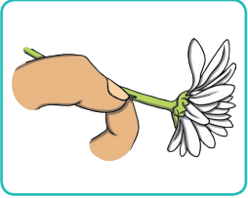 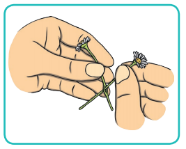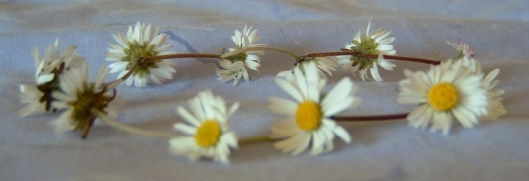

Gratitude

 Scavenger Hunt 

* 1. Find something that makes you happy.
* 2. Find something that is your favourite colour.
* 3. Find something that is soft and snuggly.
* 4. Find something that tastes good.
* 5. Find something that makes you laugh.
* 6. Find something useful to you.
* 7. Find something that makes a lovely sound.
* 8. Find something in the morning that you enjoy.
* 9. Find something that smells amazing.
* 10. Discover something new!



My Summer Nature Walk

I see...

I hear...

I feel...

I smell...

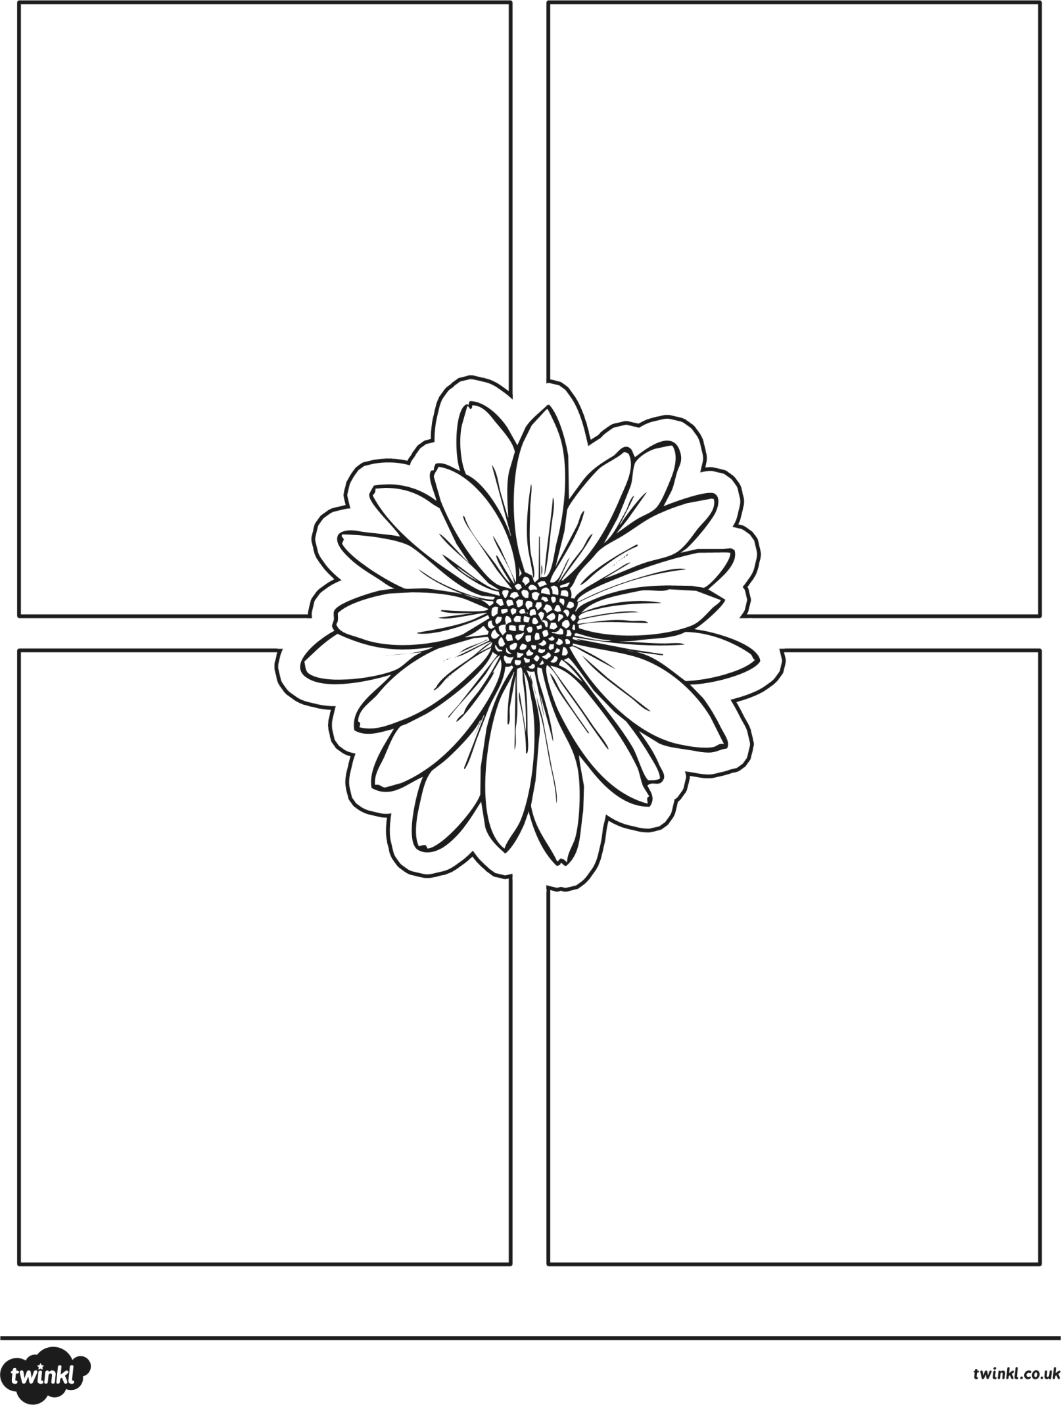

|  |  |
| --- | --- |
| Phonics Read and Draw | |
| I can see a fox. |  |
| The fox is red. |  |
| The fox can run. |  |
| The fox can jump. |  |
| The fox is on the road. |  |

|  |  |
| --- | --- |
| Phonics Read and Draw | |
| The yellow bat can fly. |  |
| Here is a red box. |  |
| This is a small blue cat. |  |
| I can see a big green fish. |  |
| The small pink dog is on the big yellow bed. |  |