Charleville National School

Class: 5th and 6th Class | Teacher: Ms Foster Date: 8th -12th June

Core Subjects (Recommended to be completed daily):
Monday | Literacy  - English in Practice (Day 134-137)  - War Horse Chapters 13-16  - Above the Clouds- The Holocaust  - P 236 A – 4-6 B – 1-6  Maths  - Mental Maths Day 1 (Week 35)  - Look at the Chance Vocabulary sheet  - Play the Chance Power point quiz.  - Home/School Links Sheet 33 Chance (look for Home School Links 5th Class in folder on website)  - Home/School Links Sheet 34 Chance (look for Home School Links 6th Class in folder on website)  - Practice your tables using Topmarks ‘Hit the button’ game  - https://www.topmarks.co.uk/maths-games/hit-the-button  - 5th Class Busy at Maths p 177 Tutorial 102  - 6th Class Busy at Maths p 178  Gaeilge  - Verb (Faigh) AC - Fuair  - RíRá – Aonad 22 - An Bhfuil agus An Raibh – p 60
Tuesday | Literacy  - English in Practice (Day 134-137)  - War Horse Chapters 13- 16  - Above the Clouds- The Holocaust  - P 236 C – Vocabulary Work D – Suffixes  Maths  - Mental Maths Day 2 (Week 35)  - Practice your tables using Topmarks ‘Hit the button’ game  - https://www.topmarks.co.uk/maths-games/hit-the-button  - 5th Class Busy at Maths p 178  - 6th Class Busy at Maths p 179  Gaeilge  - Verb (Faigh) AL - Faigheann  - RíRá – Aonad 22 An Bhfuil agus An Raibh – p 61
Wednesday | Literacy  - English in Practice (Day 134-137)  - War Horse Chapters 13- 16  - Write a summary (one page) about what you have read so far in ‘War Horse’  Maths  - Mental Maths Day 3 (Week 34)  - Practice your tables using Topmarks ‘Hit the button’ game  - https://www.topmarks.co.uk/maths-games/hit-the-button  - 5th Class Busy at Maths p 179  - 6th Class Busy at Maths p 180  Gaeilge  - Verb (Faigh) AF – Gheobhaidh  - RíRá – Aonad 23 Troid sa Chlós– p 62
Thursday | Literacy  - English in Practice (Day 134 – 137).  - War Horse Chapters 13 - 16  - Spellwell Week 28  Maths  - Mental Maths Day 4 (week 35)  - Practice your tables using Topmarks ‘Hit the button’ game  - https://www.topmarks.co.uk/maths-games/hit-the-button  - 5th Class Busy at Maths p 180  - 6th Class Busy at Maths p 181  Gaeilge  - Verb (Faigh) – All  - RíRá – Aonad 23 Troid sa Chlós– p 63
Friday | Literacy  - English in Practice (Day 134 - 137)  - War Horse Chapters 13 - 16  - Spellwell Week 28  - Maths  - Mental Maths - Friday Test (Week 35)  - Practice your tables using Topmarks ‘Hit the button’ game  - https://www.topmarks.co.uk/maths-games/hit-the-button  - 5th Class p 181  - 6th Class p. 182  Gaeilge  - Verb – test yourself on the verb Faigh  - Complete the verb activity sheet below

Other Subjects  (Ongoing throughout the week,  as suits your family schedule) | Get Creative! Get Moving!  (Activities to break up the day and get those imaginations and bodies moving!)

SESE  - Magical Instant Ice Cream  - https://www.bbcgoodfood.com/recipes/magical-instant-slushies  - Small World Geography/ Science  - Unit Study of a Bogland Area p. 74  - Some of you may be visiting the bog to ‘foot’ your turf at the moment!!  - Bog Project – see details in the folder  - Due June 12th  SPHE  6th Class:  I have added a booklet to your folder about transitioning to Secondary School. Look through it and see if there are any parts that will help you. It is called ‘From Big Fish to Little Fish’  Mindfulness Quotes colouring sheets - https://content.twinkl.co.uk/resource/85/c6/roi2-p-29-mindfulness-quotes-colouring-activity-sheets.pdf?__token__=exp=1589818289~acl=%2Fresource%2F85%2Fc6%2Froi2-p-29-mindfulness-quotes-colouring-activity-sheets.pdf%2A~hmac=c2d837b881fb023742604e616399d2089067528630d947f4f37cadb547ea3b45 | PE  - Joe Wicks (the Body Coach) is doing a daily live PE lesson online This will also be available afterwards on his YouTube channel.  - Water safety is very important for children to learn especially this time of year. Please look at the link below to do some of the Water Safety activities.  - https://www.teachpaws.ie/  Art  - @WillSliney is currently doing a daily drawing challenge for children.  - There are lots of ideas below for Summer Art  - https://masterpiecesociety.com/celebrate-summer-mixed-media-workshop/  Music  - DabbleDoo Music lessons, they have opened up access to parents. This can be accessed at: https://dabbledoomusic.com/p/parents-subscription-full-access/?product_id=1122889&coupon_code=20392I  - You will need to scroll to the bottom of the page, and click “enrol in course for free”. This will open up all the music resources for you.  Just for fun!  - Magical Instant Ice Cream  - https://www.bbcgoodfood.com/recipes/magical-instant-slushies  - Board games  - Card games  - https://www.kidspot.com.au/things-to-do/kids-games/indoor-play/snap-12-classic-card-games-to-teach-the-kids/news-story/1d153893aee53908749c1377c588928c  - Playing outside – skipping, football, dancing,  - Some nice ideas for activities on this website  - https://frugalfun4boys.com/  - Create and make up games with your siblings

War Horse Link
http://joepvk.com/warhorse.pdf
Audio Version
http://www.audioobook.com/us/free/war-horse-dwpkj53.html

Hi 5th and 6th Class,
Can you believe we are in June already? Last month of the school year!! 6th Class, please have a look at the booklet ‘From Big Fish to Little Fish’ as it will help with transitioning to Secondary School. I hope that you are all keeping well and enjoying this wonderful weather.
All the best,
Ms Foster
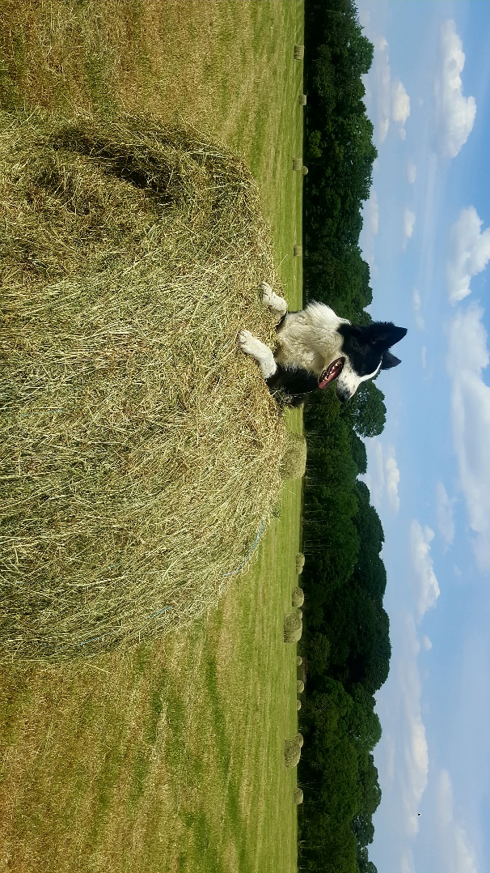
Jack enjoying the sunshine!!

Please make sure that you correct your Mental Maths and English in Practice daily (link for answers on the school website)

- You do not have to print off any power points or sheets given. Activities on sheets can be done in copies.
- Answers for Maths and Irish will be put up on the website daily so you can correct your work.
- All textbooks are on the CJ Fallon website and are free to access.
- You can also access the Maths tutorials here too.

Faigh- to get
Aimsir Chaite  Fuair mé  Fuair tú  Fuair sé  Fuair sí  Fuaireamar  Fuair sibh  Fuair siad  Ní bhfuair mé  An bhfuair tú? | Aimsir Láithreach  Faighim  Faigheann tú  Faigheann sé  Faigheann sí  Faighimid  Faigheann sibh  Faigheann siad  Ní fhaigheann mé  An bhfaigheann tú | Aimsir Fháistineach  Gheobhaidh mé  Gheobhaidh tú  Gheobhaidh sé  Gheobhaidh sí  Gheobhaimid  Gheobhaidh sibh  Gheobhaidh siad  Ní bhfaighidh mé  An bhfaighidh tú

1. (Faigh sinn) báinne ar scoil gach lá.

2. (Faigh sé) bonn óir nuair a bhuaigh sé an rás.

3. (Faigh tú) ispíní i siopa na bhúistéara de ghnáth.

4. (Faigh sibh) an ríomphost an tseachtain seo caite.

5. Ní (faigh sí) bronntanas ó Uncail Leo anuraidh.

6. (Faigh mé) airgead póca ó Mhamaí Dé Sathairn seo chugainn.

7. An (faigh tú) bronntanas ó Dhaidí Dé hAoine seo chugainn?

8. An (faigh siad) sú oráiste tar éis cluichí?

9. (Faigh sé) airgead agus ceannóidh sé liathróid nua.

10. (Faigh mé) cárta Nollag gach bliain.

