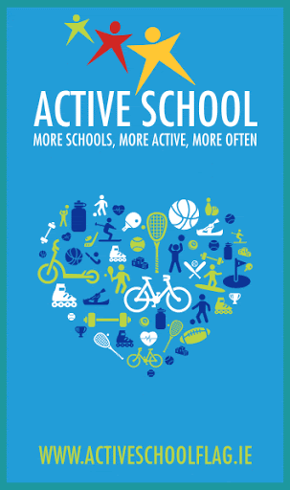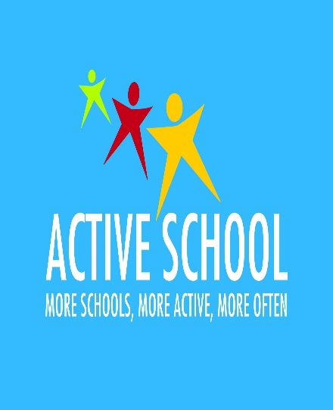

Active School Flag

Active School Flag (ASF) is a Department of Education and Skills initiative supported by Healthy Ireland.

In Charleville National School, we are working towards applying for Our Active School Flag. Our Active School Co – Ordinator is Ms Foster and we have an excellent Active School Committee.

See the Active School website https://activeschoolflag.ie/ for more information about The Active School Programme.

What are we trying to achieve?
- To Promote Physical Health.
- To enjoy being active.
- To ensure everyone has fun and feels included.
- To promote positive mental health through being active.
- To become a more active school.

Our Active Slogan
We had a competition in school to come up with an active slogan. The children were extremely creative and the committee had a tough decision to make. In the end, we blended two choices to make this slogan.
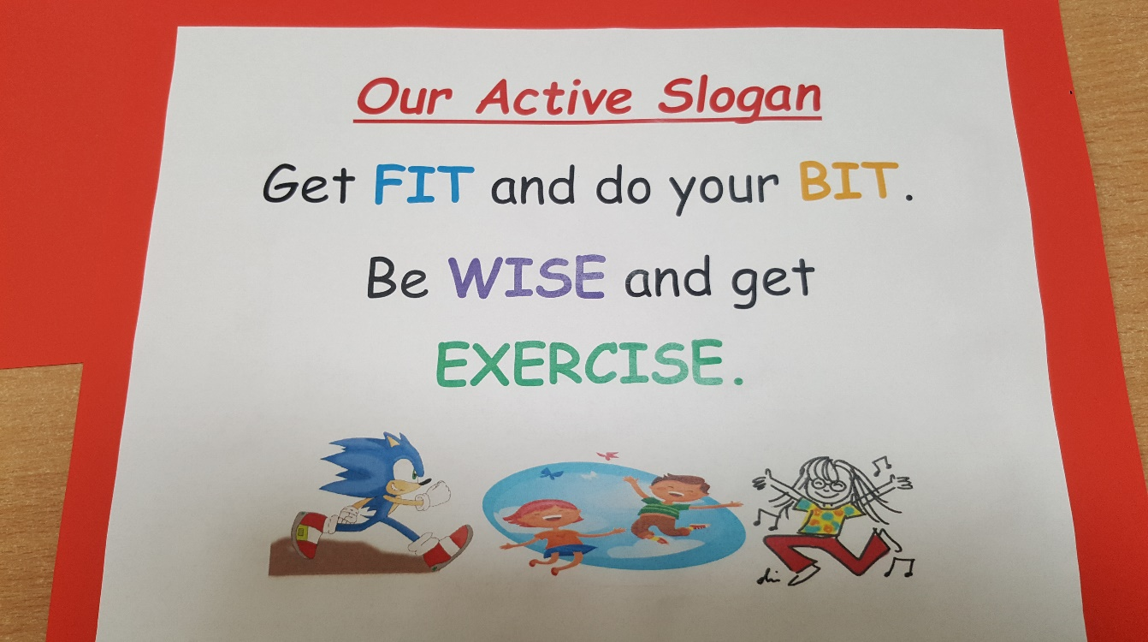

Our Active School Notice Board
We have an Active School Notice Board displayed in the school corridor so that everyone can see what different things we are doing to be active. Make sure to have a look!!
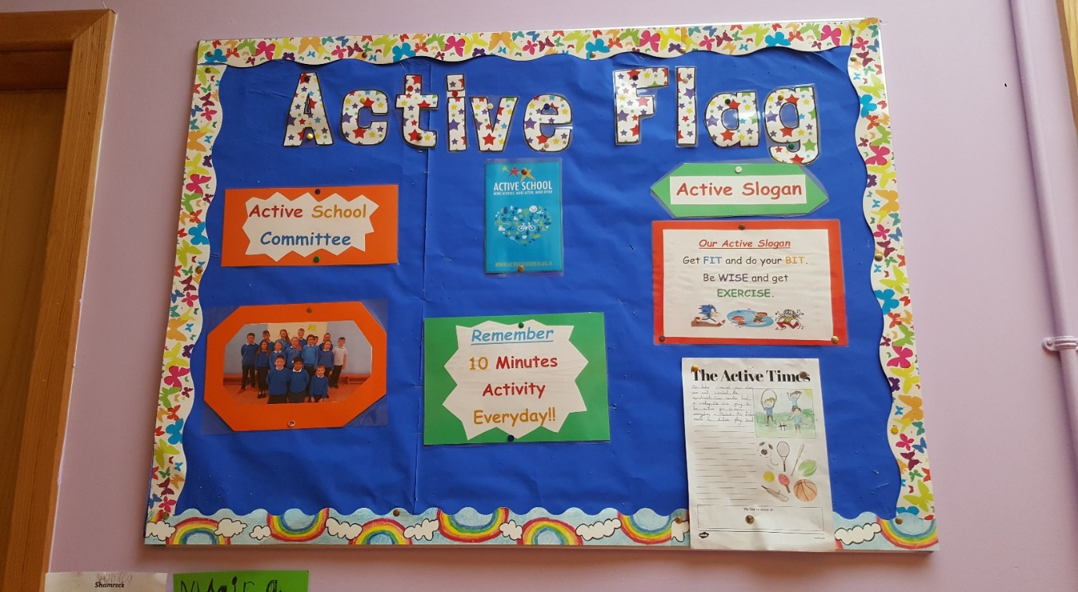
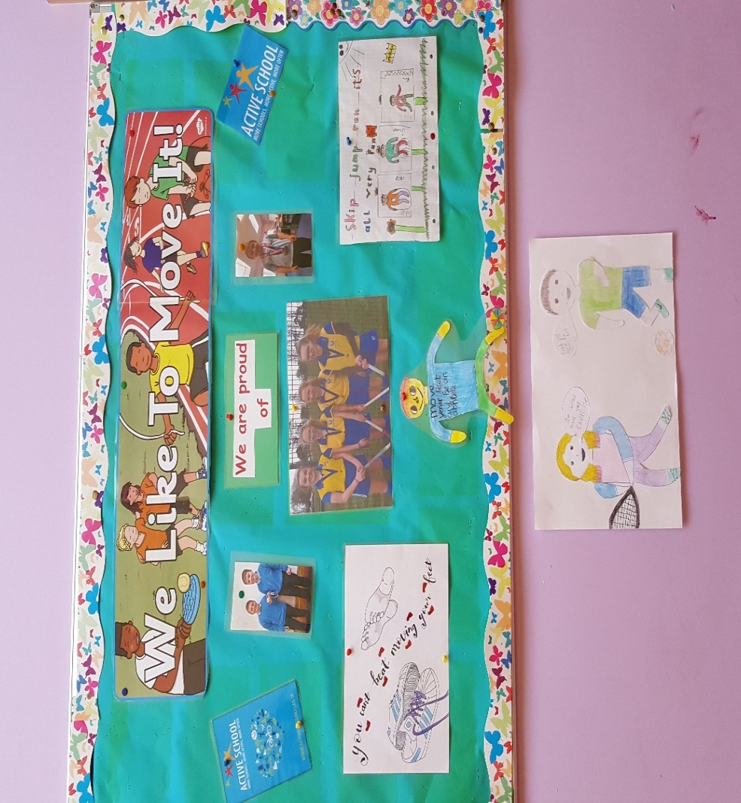
PE Store
Ms Foster along with 5th and 6th Class have spent a lot of time organising and labelling everything in our PE Store. We have purchased some new Athletics equipment, soft balls, bouncy balls, tennis balls and basketballs for all of the children to use in PE lessons.

The Daily Mile
As part of our Active school Flag, we are taking part in ‘The Daily Mile’. ‘The Daily Mile’ is a social physical activity, with children running or jogging – at their own pace – in the fresh air with friends. Children can occasionally walk to catch their breath, if necessary, but should aim to run or jog for the full 10minutes.
As a school, we are really excited about this initiative and we are looking forward to the benefits it will bring to your child/children. You can find out more about ‘The Daily Mile’ by visiting https://thedailymile.ie/
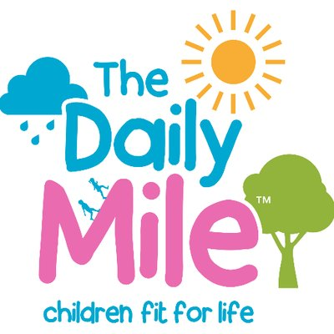

Partnerships
We are taking part in many Partnerships.
- Zumba with Dorinda
- Offaly Sport’s Partnership
- Rugby with Tullamore Rugby Club
- Movement Screening Programme with Physio Tullamore
- Fyffes Fitness Squad
- Aldi School Rugby

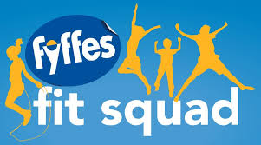
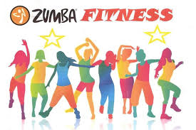

Active Breaks
Every class completed the active break challenge of 10 minutes activity a day.
