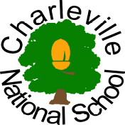§

Charleville National School

Class: 2nd Class | Teacher: Miss Finlay | Date: 8th – 12th June 2020

Core Subjects (Recommended to be completed daily):
Extra Maths Sheets | Extra Maths worksheets on each mathematical topic can be found in the ‘Busy at Maths  Home-School Links’ workbook.
Note | The Irish videos are linked.  The Twinkl worksheets are linked.
Monday | Literacy  - English in Practice, Day 139  - Spell Well, Week 35  - Read personal book aloud  - Complete the next page in your handwriting book  Maths  - Busy at Maths 2, p. 151  - Mental Maths, Week 34  - Tables -6 and -7  Gaeilge  - Watch Irish videos entitled ‘Amhran and Dan’ and ‘Vocabulary’  - Repeat words  - Set up a FolensOnline account https://www.folensonline.ie/home/  - Select 1st and 2nd Class  - Click ‘Abair Liom C’  - Select Resources  - Open the fourth option on page 6 ‘Póstaer – ‘Oisín Tinn’ ‘  - Listen to the vocabulary and phrases in Cuardach 2  - Play Foclóir 1  New Phrases  Pian - Pain  Tinn – Sick  Leigheas – Medicine
Tuesday | Literacy  - Rainbow Skills 2, p.91 – Write a question for each answer  - English in Practice, Day 140  - Spell Well, Week 35  Maths  - Busy at Maths 2, p.152  - Mental Maths, Week 34  - Tables -6 and -7  Gaeilge  - Click ‘Abair Liom C’  - Select Resources  - Open the fourth option on page 6 ‘Póstaer – ‘Oisín Tinn’ ‘  - Revise Cuardach 2  - Play Foclóir 2  - Listen to the scéal
Wednesday | Literacy  - Rainbow Skills 2, p.92 – Find the odd one out.  - English in Practice, Day 141  - Spell Well, Week 35  Maths  - Busy at Maths 2, p.153  - Mental Maths, Week 34  - Tables -6 and -7  Gaeilge  - Revise the ‘Amhran and Dan’ video to learn the words for today’s Irish song  - Click ‘Abair Liom C’  - Select Resources  - Open the fourth option on page 6 ‘Póstaer – ‘Oisín Tinn’ ‘  - Sing along with the amhrán
Thursday | Literacy  - Rainbow Skills 2, p.93 – Choose the correct adjective  - English in Practice, Day 142  - Spell Well, Week 35  - Read personal book aloud  Maths  - Busy at Maths 2, p.154  - Mental Maths, Week 34  - Tables -6 and -7  Gaeilge  - Revise the ‘Amhran and Dan’ video to learn the words for today’s Irish poem  - Click ‘Abair Liom C’  - Select Resources  - Open the fourth option on page 6 ‘Póstaer – ‘Oisín Tinn’ ‘  - Say the dán
Friday | Literacy  - Rainbow Skills 2, p.94 – Match each word to its meaning  - English in Practice, Day 143  - Spell Well, Week 35  - Read personal book aloud  Maths  - Busy at Maths 2, p.155  - Mental Maths, Week 34  - Tables -6 and -7  Gaeilge  - Revise the ‘Amhran and Dan’ video to learn the words for today’s Irish poem  - Click ‘Abair Liom C’  - Select Resources  - Open the fourth option on page 6 ‘Póstaer – ‘Oisín Tinn’ ‘  - Answer the ceisteanna

Other Subjects  (Ongoing throughout the week,  as suits your family schedule) | Get Creative! Get Moving!  (Activities to break up the day and get those imaginations and bodies moving!)
SESE – Summer, Rainbows, and the Wind and Sun story  Science – Summer  - Read through the Twinkl PowerPoint on Summer  - Complete page 85 on Summer in Small World 1  Geography – How are Rainbows formed?  - Watch the video below  https://www.youtubekids.com/watch?v=nCPPLhPTAIk&hl=en-GB  - Carry out the experiment mentioned at the beginning of the video or come up with a mnemonic to help remember the colours of the rainbow in order  - Example:  - Red, orange, yellow, green, blue, indigo, violet.  - Richard of York gave battle in vain  - Really old yoyos grow bigger in volcanos  - The sillier, the better ☺  History – The Wind and the Sun  - http://www.umass.edu/aesop/content.php?n=31&i=1  - Read the story of ‘The Wind and the Sun’  - The moral of the story is that kindness is stronger than cruelty  - Re-enact the story for your family by yourself or with a sibling  - Pretend you are a news reporter and make a video about the competition between the wind and sun  SPHE  - Empathy is a very important skill for children to develop from an early age.  - Please listen to the story ‘I am Human.’  - https://www.youtube.com/watch?v=X9RxO3HG9bM  - Pause the video and examine the pictures.  - Ask your child questions about what’s happening in each image.  - Discuss their dreams and hopes for the future, the people who are important, whether they ever feel hurt, have they ever hurt others ,whether they have to say sorry sometimes.  - Consider whether the things that were true for them may be true for others  - Explain that everyone is human and that all deserve to be treated with equal kindness and respect | PE  - This week we are going to be working on skipping  https://vimeo.com/417539946  Art  - Create a sun picture. Paint an orange circle in the centre of a page. Trace the outline with black paint. Paint the sky blue. Let your painting dry. Find scraps of cards or wrapping paper. Cut out rays to surround the sun. Use the sun to remind you to be kind. 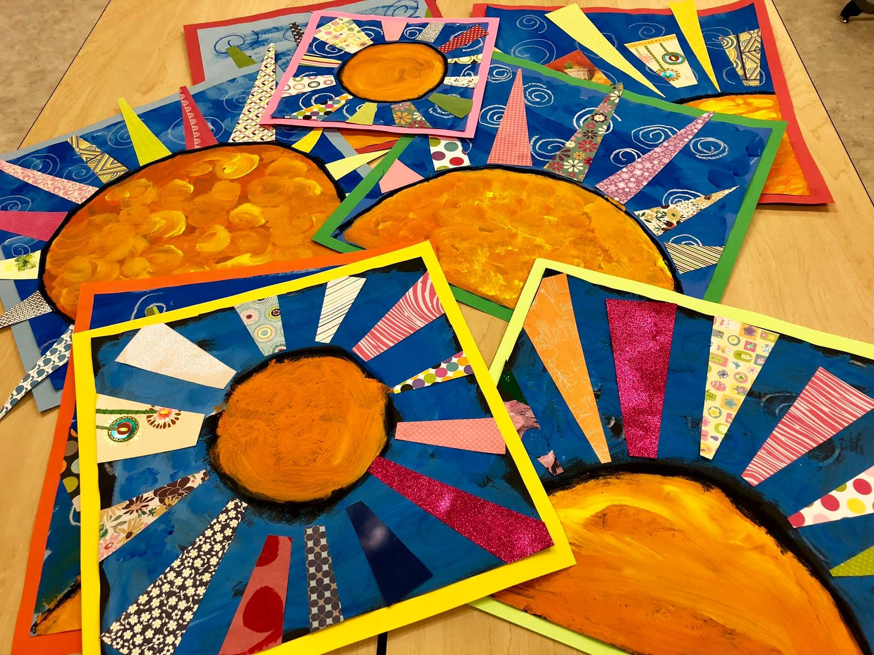  Music  - We use DabbleDoo Music for music lessons, They have opened up access to parents. This can be accessed at: https://dabbledoomusic.com/p/parents-subscription-full-access/?product_id=1122889&coupon_code=20392I You will need to scroll to the bottom of the page, and click “enrol in course for free”. This will open up all the music resources for you.  - Please complete the lesson on the ‘Don’t Worry Be Happy,’ pop song which can be found in the free content section. https://dabbledoomusic.com/courses/369926/lectures/5733607  Just for fun!  - Practice your favourite ‘Just Dance’ routine and make your own dance video. Here’s a song suggestion. https://www.youtube.com/watch?v=l6HQSqyriK8  - Cook or bake something and film the process. You can pretend you are a famous chef with your own cooking show.  - Make a fort out of blankets, chairs and pillows. Make sure to ask for permission. Read, eat snacks or watch a movie in your fort.

